# Lab: Introduction to JavaScript

Problems for exercises and homework for the ["JavaScript For Front-End Course @SoftUni"](https://softuni.bg/trainings/2032/javascript-for-front-end-july-2018#lesson-8965). Submit your solutions in the SoftUni judge system at <https://judge.softuni.bg/Contests/1094/>.

## Calculate

Write a JavaScript program to print the value of the following expression:

* (30 + 25) + ((35 – 14) * 2)

function solve() {  
 //TODO: Write your code here...  
}

## Bigger Number

Write a JavaScript program with **two numbers** and print bigger of them.

### Examples:

|  |  |  |  |  |
| --- | --- | --- | --- | --- |
| **Input** | **Output** |  | **Input** | **Output** |
| 10  20 | 20 |  | 66  4 | 66 |

### Hints

* Use **If** – **Else** statements

function solve(input) {  
 let firstNumber = Number(input[0]);  
 let secondNumber = Number(input[1]);  
 //TODO: Write your code here...  
}

## First 20 Numbers

Write a JavaScript program, which prints first 20 numbers.

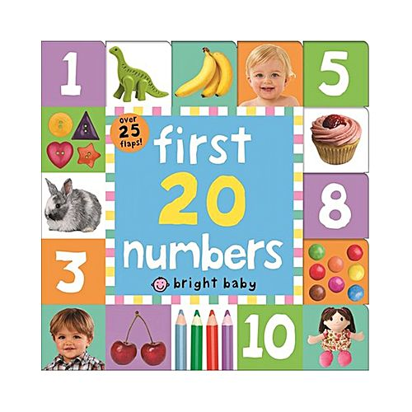

function solve() {  
 //TODO: Write your code here...  
}

## Print the elements in array

Write a JavaScript program, which print all array elements.

### Examples:

|  |  |
| --- | --- |
| **Input** | **Output** |
| **let elements = [1, 2, 3, 4, 5];** | 1  2  3  4  5 |

|  |  |
| --- | --- |
| **Input** | **Output** |
| **let elements = [aaa, ooo, uuu];** | aaa  ooo  uuu |

function solve(input) {  
 let elements = input;   
 //TODO: Write your code here...  
}